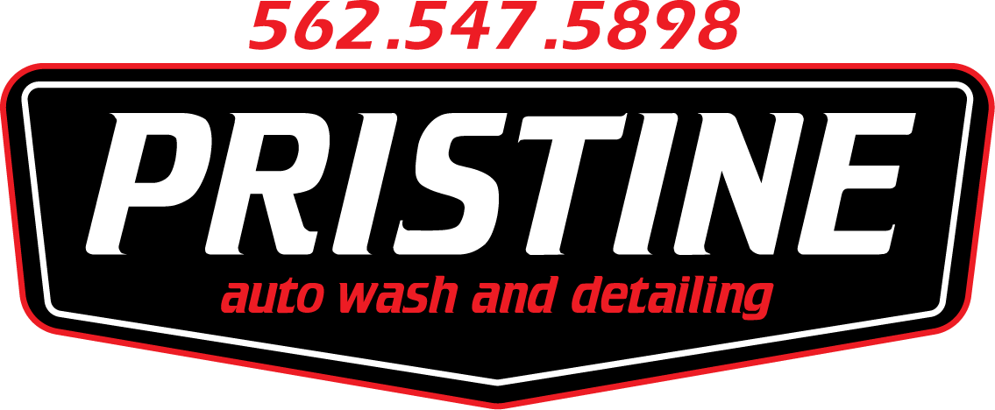 Detailing Acknowledgement Form

Pristine Auto Wash And Detailing -- Terms & Conditions
Pristine Auto Wash And Detailing seeks to provide the best complete mobile detailing service experience. We would like to take this opportunity to thank you for considering our services and point out some of the terms and conditions of our business criteria. We hope you will find these policies listed below helpful and informative in explaining the extent of our auto detailing services.
By scheduling any service with Pristine Auto Wash And Detailing you hereby agree to all the terms listed below.
- Being a mobile service we come to you expecting to have the following: An ample amount of space to perform our service, permission to be on-premises if you are not the owner and a safe location as well as safe conditions to service your vehicle. If we arrive and the previously mentioned conditions are not met, we reserve the right to reschedule the service at a later time/date that works for both parties. In addition, the deposit will be lost.

  - If the service is provided at your home, please make sure to have all vehicles that will be leaving adjusted so we do not have to break down our setup to allow them to move.
  - If you have scheduled an appointment at our location, please understand that it is not a “detail shop” but our garage at our home that we have equipped to take customers. We do not have a waiting room so customers must arrange to drop the vehicle off. Please give us ample notice via phone call or text to set up a time to drop the vehicle off.
- We require payment to be made in full on the day of the scheduled service. If the customer is not present they can leave payment in cash or use apps(Venmo, Cashapp, Zelle, and Paypal) or we will send an invoice via email that must be paid in full the same day. Failure to pay in full on the same day will result in a 10% late charge accrued each month if left unpaid.

- We require a 24-hour notice to cancel any booking/detailing service. Failure to do so will result in a $20 rescheduling fee.
  - We reserve the right to charge up to 1/2 of the scheduled detailing service if canceled by the customer on the day of said scheduled service unless extreme circumstances could not allow you to keep the scheduled service.
  - We reserve the right to charge a $50 non-refundable retainer if the customer has canceled and rescheduled multiple times.
  - We reserve the right to alter or amend an appointment time/date without penalty to the company but wherever possible will let the customer know.
  - We reserve the right to alter an appointment or move an appointment in accordance with weather conditions and/or equipment failure without penalty to the company.
- Our estimated time of arrival for our mobile services may depend on the weather, traffic, or other unforeseen circumstances.
  - We will contact you the day before the scheduled appointment to confirm, give you an estimated time of arrival, and make sure the weather is permitting us to work.
  - We will contact you on the day of the appointment if we are running late or ahead of schedule.
- Please remove all personal belongings, money and other significant items from their vehicle prior to any type of detail.
  - If areas such as the center armrest storage or glove compartment are not cleared, we will not be able to clean them due to customer’s private personal belongings.
  - Due to child safety, we will not remove or replace car seats under any circumstances. We ask that our clients remove car seats and booster seats before we arrive. Should the car seat be left in the vehicle we will do our best to clean around the car seat but can’t promise your total satisfaction.
- We reserve the right to charge each vehicle according to its condition, the type of vehicle and the customer location.
  - We reserve the right to amend any price during the detailing should it differ from the original price.
  - A minimum of 10-20$ surcharge will be applied to all jobs that involve excessive pet hair, urine, vomit, blood, feces, or other hazardous materials.

  - Pet hair and sand are two of the toughest items to remove from a vehicle with normal vacuuming. The removal of either element is not guaranteed with any of our service offerings. However, on most occasions we are successful at removing visual traces of both elements.
- We make no promises to being able to remove all stains or odors from vehicles. We aim to please so we will always consult you on what can and cannot be done in regards to the interior of your vehicle.
  - Odors cannot be removed by cleaning alone. Depending on odor and how long it has been saturated in vehicle price for removing will depend on the amount of work to be done in order to remove odor.
- When it comes to windows we try to be our best. But from time to time and depending on temperature windows may have a film. Please allow the car to cool and then take a microfiber towel and wipe the film off if you see streaks. We do apologize for any inconvenience this may cause.
- We are not responsible for damage due to heavily soiled, stained or damaged interior components, such as dash buttons and steering column buttons and knobs. Such areas may be so caked with dirt, grime, and makeup that cleaning may result in these buttons and knobs losing their markings.
- The headliner is gently cleaned, however, there may be remaining stains. The glue used for headliners will start to release if cleaned more aggressively or with stronger cleaners. Please understand that headliners may not come completely clean due to this reason.
- We do not use harsh cleaning products on any interior or exterior areas. All of our products are safe and do not chemically damage carpets, leather, vinyl, plastic, painted, clear coated, or chrome surfaces.
- We are not responsible for baked-on brake dust that cannot be completely removed either on the surface or deep within the wheel. Some wheels are beyond cleaning and may need to be repaired or replaced.
- Bird droppings, bug splatter, sap, and tar will chemically etch into your vehicle’s paintwork if left for a period of time. This will result in a deep chemical mark on the paintwork that may need additional work to safely remove. In some cases, the mark cannot be removed completely without comprising the clear coat.
- Exterior black or grey, textured or smooth trim pieces may be beyond restoring and will have to be replaced. We try our best to restore the plastic to its original color.
- Any wax, sealant or coating not properly cared for will not last it's intended durability length. We recommend safely hand washing.
- We respect your time and personal property and we will be polite and courteous at all times.
  - However, we reserve the right to refuse, deny or continue with any service if we deem the customer to be unreasonable.
  - We will not tolerate any verbal or physical abuse under any circumstances and will take the relevant actions should any such behaviors be encountered

17. For your safety please keep a safe distance, at least 10-15 feet away from our work area to avoid any trip or slip hazards. If you need to speak to us while we are working on your vehicle please make sure to get our attention from a distance. We try to pay attention to our surroundings

Please read each service provided to understand what is involved with our services.
Maintenance wash
Interior.
A quick wipe down of dashboard, center console, all doors and door jams. Carpet, floor mats, and seats thoroughly vacuumed. Windows are clean and left streak-free. The final interior fragrance is then sprayed.
Exterior.
Your vehicle is foamed washed and cleaned with a microfiber mitt then rinsed off with distilled water. The vehicle is then dried with microfiber towels and pressured air is used to remove and excess water from any cracks and crevices as windows get cleaned and left streak-free. Wheels and tires cleaned and tires are dressed for a final touch.
Mini detail
Interior.
A complete wipe down of the dashboard and center console, all doors and door jams. A dressing (UV protectant) is applied to the dashboard, center console, and doors. Carpet, floor mats, and seats are thoroughly vacuumed. Windows are clean and left streak-free. The final interior fragrance is then sprayed.​
Exterior.
Your vehicle is foamed washed scrubbed with a microfiber mitt and rinsed off with distilled water then dried with a microfiber towel and with pressured air-dried from any excess water as windows get cleaned and then left streak-free. Then spray a synthetic Xpress wax to bring out that shine to your vehicle. Wheels and tires are degreased and tires are dressed for the final touch.
Pristine Detail
Interior.
Complete cleaning on all doors, dashboard, center console, plastic trim and door jams. A dressing (UV protectant) is applied to the dashboard, center console, doors, and all plastic trim. Carpet, floor mats, and seats get thoroughly vacuumed. Rubber mats get cleaned of all dirt and grime. Windows are cleaned and left streak-free. The final interior fragrance is then sprayed.
​
Exterior.
Your vehicle is rinsed off then foamed washed and cleaned with a microfiber mitt and rinsed off with distilled water. The vehicle is then foamed up again and a clay bar is then used to remove all contaminants on the painted surfaces. The vehicle gets foamed one last time and rinsed and dried with a microfiber towel and pressured air is used to remove any excess water as windows get cleaned and left streak-free. Then we apply wax to bring back that shine to your vehicle. Wheel wells, wheels, and tires are degreased and tires are dressed for the final touch.
The Pristine Detail is a Paint Refinement service meant to add gloss and reduce some swirls, hazing, and oxidation on the paintwork. Wax protects the paintwork with a paint sealant lasting 4-6 months.
The 1- Step polish is a Paint Enhancement service meant to safely remove/reduce swirls, hazing, oxidation, water spots and other paint defects to the best of our ability. Some paint defects and heavy scratches will remain due to them being too deep to remove without compromising the clear coat. Wax protects the paintwork with a paint sealant lasting 4-6 months. However, any wax, sealant or coating not properly cared for will not last it's intended durability length. Please ask us how to properly care for the exterior of your vehicle.
Customer signature:______________________________________________________

